**Release Plan**

Written Report

**Team 2**

Team Member:

Bhavsar, Dhruvit Vibhakar

Koshti, Khushboo

Lamichhane, Nishan

Liu, Ziyan

Virk, Ranvir

COMP231(Sec.007)

November 12, 2023

Professor : llir Dema

Centennial College

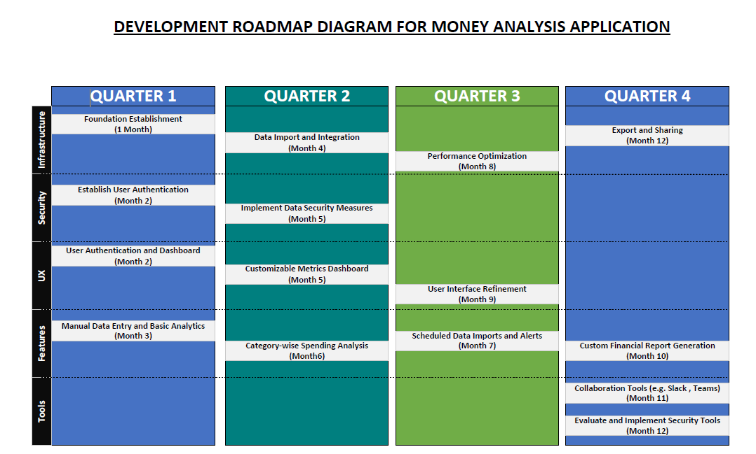

|  |
| --- |
| Release 1: Foundation & Core Features (Quarter 1)    1. Foundation Establishment (Month 1)   * Set up the core development environment and version control. * Establish a secure and scalable database structure.   2. User Authentication and Dashboard (Month 2)   * Implement basic user authentication. * Design and deploy the main dashboard for users.   3. Establish User Authentication (Month 2)   * Multi-Factor Authentication (MFA) Implementation: * Integrate a robust multi-factor authentication system to enhance the security of user accounts. * Require users to authenticate through multiple factors such as passwords, one-time codes, or biometrics. * OAuth/OpenID Connect Integration: * Implement OAuth or OpenID Connect protocols to enable secure and standardized authentication. * Allow users to log in using existing accounts from trusted identity providers, enhancing both security and user convenience.   4. Manual Data Entry and Basic Analytics (Month 3)   * Develop a simple data entry form for manual transaction input. * Enable users to view a summary of their spending on the dashboard. |
| Release 2: Data Integration & Enhanced Dashboard (Quarter 2)  5. Data Import and Integration (Month 4)   * Implement a data import feature for users to upload financial data. * Integrate with popular financial platforms (e.g., banks, apps).   6. Customizable Metrics Dashboard (Month 5)   * Introduce a customizable dashboard, allowing users to prioritize financial metrics. * Implement the ability for users to configure and save different dashboard layouts.   7. Implement Data Security Measures (Month 5)   * Data Encryption for Transit and Rest: * Apply encryption mechanisms to protect data both in transit and at rest. * Utilize secure communication protocols (e.g., HTTPS) for data transmission and encrypt sensitive data stored in databases. * Regular Security Audits and Penetration Testing: * Conduct regular security audits to identify vulnerabilities and potential threats. * Perform penetration testing to simulate cyber-attacks and assess the resilience of the application's security measures.   8. Category-wise Spending Analysis (Month 6)   * Enable users to categorize transactions and analyze spending by specific expense categories. * Provide clear visual breakdowns of expenses by category. |
| Release 3: Automation & Alerts (Quarter 3)  9. Scheduled Data Imports and Alerts (Month 7)   * Allow users to schedule recurring data imports for automated updates. * Implement automated alerts for specific financial events or thresholds.   10. Performance Optimization (Month 8)   * Conduct thorough performance testing. * Optimize application speed and responsiveness.   11. User Interface Refinement (Month 9)   * Collect user feedback on the interface. * Refine UI elements for a polished user experience. |
| Release 4: Collaboration & Reporting (Quarter 4)  12. Custom Financial Report Generation (Month 10)   * Develop a feature for users to create custom financial reports. * Include options for selecting different time frames and data parameters.   13. Collaboration Tools (Month 11)   * Introduce collaboration features for sharing datasets and analysis scripts. * Implement user roles and permissions for team collaboration.   14. Export and Sharing (Month 12)   * Enable users to export reports in various formats (PDF, CSV). * Implement sharing options for reports and insights.   15. Evaluate and Implement Security Tools (Month 12)   * Vulnerability Scanning Tools: * Evaluate and deploy automated vulnerability scanning tools. * Regularly scan the application and its dependencies for known vulnerabilities, ensuring timely identification and mitigation. * Intrusion Detection and Prevention Systems (IDPS): * Explore and implement IDPS to monitor network and system activities for malicious behavior. * Configure the system to detect and prevent security incidents, providing real-time protection against potential threats. |
| Key Considerations:   * User Feedback Loops: Collect user feedback after each release to inform subsequent development. * Agile Adaptation: Be ready to adapt the roadmap based on changing requirements, user feedback, and emerging technologies. * Continuous Improvement: Foster a culture of continuous improvement in both the product and development processes. |

### **Must-Have**

|  |  |  |  |
| --- | --- | --- | --- |
| **Feature** | **User Role(s)** | **Importance** | **User Benefit** |
| Add New Spending | Regular User | Crucial for recording personal transactions | Ensures easy recording of daily spendings and earnings, from morning coffees to extra cash, maintaining a comprehensive financial record. |
| Home Page | Regular User | Essential for quick access to financial info | Acts as a financial command center, providing a quick snapshot of current balances and monthly spending, making it easy for users to manage their money effectively. |
| Investment Portfolio | Premium User | Vital for managing assets and investments | Organizes all investments and assets in one place, serving as a virtual manager for financial growth and providing users with a centralized view of their financial world. |
| Reporting and Analytics | Administrator | Important for monitoring system performance | Serves as a backstage pass, generating reports and analytics to ensure the app runs smoothly and efficiently, offering insights into user activity and system performance. |
| View User Profile | Financial Advisor | Necessary for providing personalized guidance | A comprehensive guide for financial advisors, offering user details from account numbers to contact information, facilitating the delivery of personalized financial advice. |

### **Should-Have**

|  |  |  |
| --- | --- | --- |
| **Feature** | **User Role(s)** | **Importance** |
| Detailed Monthly Transaction | Regular User | Significant for understanding spending by category |
| Detailed Category Transaction | Regular User | Valuable for analyzing transactions in spending categories |
| Premium Customer Support | Premium User | Useful for expert assistance during critical situations |
| User Management | Administrator | Important for controlling user access effectively |

### **Could-Have**

|  |  |  |  |
| --- | --- | --- | --- |
| **Feature** | **User Role(s)** | **Importance** | **User Benefit** |
| Filter Option for Date Ranges | Regular User | Enhances user experience by filtering transactions | Allows users to easily track spending during specific periods, making it simpler to review transactions for holidays or special occasions. |
| AI-Driven Spending Recommendations | Premium User | Provides advanced insights for optimizing spending | Acts as a financial guru, studying user spending patterns and offering smart tips on how to optimize spending, providing personalized recommendations for better financial decisions. |
| Access Control | Administrator | Refines control over user access levels | Adds an extra layer of security, enabling administrators to control who can access specific features, enhancing overall security measures within the financial management application. |
| Financial Goal Setting | Premium User | Enables setting and monitoring financial goals | Supports users in setting and tracking financial goals, providing personalized tips on how to achieve them, helping users plan and achieve their aspirations, whether it's a dream vacation or a new gadget. |

### **Won't-Have**

|  |  |  |
| --- | --- | --- |
| **Feature** | **User Role(s)** | **Reason** |
| Real-Time Alerts for Investment Changes | Premium User | Excluded to keep the initial release simpler |
| User Data Backup | Financial Advisor | Not a primary concern at this stage |
| Advanced AI-Driven Spending Recommendations for Regular Users | Regular User | Excluded to avoid overcomplicating the user interface |

**Ranking User Stories from High, Medium, and Low priority:**

|  |  |  |
| --- | --- | --- |
| **High priority** | **User Role(s)** | **Reason** |
| Add New Spending | Premium and Regular User | A vital function that applies to regular and premium users is the ability to add new transactions. It is ranked first in all user categories since it is crucial for keeping track of earnings and expenses. |
| Reporting and Analytics | Administrator | System upkeep and enhancement depend heavily on user participation and system performance monitoring. It gives the administrator insightful information. |
| Home Page Overview | Premium and Regular User | The home page must be displayed to view the performance summary of their portfolio. It offers easy access to important financial data. |
| User Management | Administrator | One of the most important administrative responsibilities is managing user accounts, which enables the establishment, deactivation, and reset of passwords of user accounts. |
| Detailed Monthly Transaction | Premium and Regular User | It is critical for users to view economic data and trends to improve their awareness of their financial situation. |
| View Profile | Financial Advisor | It is crucial to view the user's profile because it provides specific information that improves financial advice. |

|  |  |  |
| --- | --- | --- |
| **Medium priority** | **User Role(s)** | **Reason** |
| Investment Portfolio Management | Premium User | For premium customers, managing investments is an essential feature. Managing assets, different investment kinds, and offering tailored advice for maximizing their investments are all part of it. |
| Premium Customer Support | Premium User | Expert customer assistance is important for premium subscribers to have access to. It highlights how crucial it is for people with premium accounts to receive top-tier priority care. |
| Detailed Category Transaction | Premium User | As with the narrative for normal users, premium users consider this feature more important as they are paying more for assessing expenditure patterns that are exclusive to their categories. |
| Access Control | Administrator | Determining that users have the right permissions and preserving system security depend on user access levels being controlled. |
| Financial Goal Setting | Premium User | Helps customers plan and fulfill their dreams, whether it is purchasing a new device or a dream vacation, by supporting them in creating and monitoring financial goals and offering tailored advice on how to get them. |

|  |  |  |
| --- | --- | --- |
| **Low priority** | **User Role(s)** | **Reason** |
| User Data Backup | Administrator | Periodically backing up user data is for data integrity and system dependability, but it is not a primary concern at this stage. |
| Detailed Category Transaction | Regular User | For frequent users, viewing transactions by category is a helpful tool for managing and analyzing their spending. |
| View Expenses, View Investment Page | Financial advisor | To give people advice and insights, financial advisors must review spending, particularly historical records. Additionally, the investment feature—which is crucial for a financial advisor—allows consumers to review their investments. |
| Real-Time Alerts for Investment Changes | Premium user | It is not important at this stage. |

**Paper Prototype:**

|  |  |
| --- | --- |
|  | **Home Page:**  On the home page, once the user logs in to their account, they can see the page with their name on the top left corner and the bank name where their credit card is related. In the center of the page is the user’s total spending for the current month. It will provide real-time data and reflect their spending every time they have a new transaction. Below that, the income and (optional) total balance on that card will also show up; this feature can be customized by the user itself. The three buttons at the bottom will direct the user to different pages; there are spending categories, analytic reports, and the ability to add a new one. |
|  | **Spending Category Page:**  On the spending category page, users are able to select a specific category and view the total spending for daily, monthly, and yearly. It also has the option for the user to sort the overall spending from the highest to the lowest or the reverse way. In the center of the page, each category will be followed by the amount of money they spend. The interface will be able to look like a horizontal bar diagram, where the user can capture the spending data more accurately |
|  | **Analytic Report Page:**  On the analytic report page, the content will be randomly selected from the back end. Based on the user’s preference and spending behavior, it will generate a series of reports like “You spent $#### so far; it’s higher than the last month.” This report can enhance the user’s experience with this app and give them a better understanding of their own money. |
|  | **Add a new transaction page:**  In the add a new transaction page, the user will enter a new transaction by themselves, whether it’s a new earning or new spending. The page will provide an input box for the amount of money they spend for that money or the amount of money they earn for that category, the category of a specific field such as food, rent, etc., and the date that the new transaction happened. Once the user clicks on the submit button, it will return to the home page, and the total of monthly spending will reflect the information. |

**Iteration Plan:**

**Iteration plan1:**

**Objective** : Establish the foundational framework and infrastructure for the Money Analysis Application.

|  |  |  |  |
| --- | --- | --- | --- |
| **Task Description** | **Assigned To** | **Beginning Date** | **Ending Date** |
| Define project scope and gather requirements | Project Lead | 12-Sep-2023 | 19-Sep-2023 |
| Conduct market research for similar app | Project Team | 12-Sep-2023 | 20-Sep-2023 |
| Set up version control and choose a repository | Dev Team | 14-Sep-2023 | 18-Sep-2023 |
| Create initial project architecture | Tech Lead | 20-Sep-2023 | 25-Sep-2023 |
| Establish coding standards and best practices | Dev Team | 26-Sep-2023 | 30-Oct -2023 |
| Choose and set up development tools and IDE | Dev Team | 26-Sep-2023 | 30-Oct-2023 |
| Implement basic file structure and directory layout | Dev Team | 26-Sep-2023 | 30-Oct-2023 |
| Create a project roadmap and milestone plan | Project Lead | 05-Sep-2023 | 12-Sep-2023 |
| Set up continuous integration and deployment | DevOps Team | 30-Sep-2023 | 30-Oct-2023 |
| Design and implement basic user authentication | Dev Team | 26-Sep-2023 | 30-Oct-2023 |
| Develop and integrate error logging and monitoring | Dev Team | 26-Sep-2023 | 30-Oct-2023 |
| Implement basic user interface wireframes | UI/IX Team | 30-Oct -2023 | 5-Nov-2023 |
| Define and configure the database schema | DB Team | 30-Sep-2023 | 30-Oct-2023 |
| Conduct a review of the initial framework | Project Team | 05-Nov-2023 | 10-Nov-2023 |
| Prepare documentation for the foundational setup | Project Team | 05-Nov-2023 | 10-Nov-2023 |

|  |  |  |
| --- | --- | --- |
| **Task Description** | **Assigned To** | **Estimated(Hours)** |
| Define personal financial goals and preferences | User(Yash) | 2hr |
| Provide input on desired features and functionalities | User(Nikhil) | 3 hr |
| Participate in user testing for initial wireframes | User(Jenny) | 2 hr |
| Share feedback on the user interface and experience | User (Pooja) | 3 hr |
| Review and approve project requirements | User(Dhruv) | 1.5 hr |
| Test the basic user authentication system | User(Elvish) | 2.5 hr |
| Validate initial database structure and functionality | User(Parth) | 4 hr |
| Review and approve the project's coding standards | User(Kelly) | 4.5 hr |
| Receive alerts for budget overspending | User(Pratik) | 2.5 hr |
| Test the initial error handling and exception reporting | User(Preeti) | 3 hr |

**Iteration plan 2:**

**Objective:** Build core functionalities and integrate the database for comprehensive money tracking.

|  |  |  |  |
| --- | --- | --- | --- |
| **Task Description** | **Assigned To** | **Beginning Date** | **Ending Date** |
| Refine and finalize project requirements | Project Lead | 05-Sep-2023 | 19-Sep-2023 |
| Complete the integration of chosen development tools | Dev Team | 30-Sep-2023 | 20-Sep-2023 |
| Implement income tracking feature | Dev Team | 30-Sep-2023 | 18-Sep-2023 |
| Develop expense tracking feature | Dev Team | 30-Sep-2023 | 25-Sep-2023 |
| Integrate income and expense functionalities | Dev Team | 30-Sep-2023 | 30-Oct -2023 |
| Implement basic reporting and analysis capabilities | Dev Team | 30-Sep-2023 | 30-Oct-2023 |
| Develop budgeting feature | Dev Team | 30-Sep-2023 | 30-Oct-2023 |
| Integrate budgeting with income and expense tracking | Dev Team | 30-Sep-2023 | 12-Sep-2023 |
| Implement data validation for financial inputs | Dev Team | 30-Sep-2023 | 30-Oct-2023 |
| Set up error handling and exception reporting | Dev Team | 30-Sep-2023 | 30-Oct-2023 |
| Create user documentation for core functionalities | Technical Writer | 1-Nov-2023 | 10-Nov-2023 |
| Conduct internal testing for income and expense modules | QA Team | 1-Oct -2023 | 5-Nov-2023 |
| Develop user interface enhancements for better usability | UI/IX Team | 20-Oct-2023 | 30-Oct-2023 |
| Implement user feedback from initial testing | Dev Team | 30-Sep-2023 | 10-Nov-2023 |
| Conduct a comprehensive review of core functionalities | Project Team | 05-Nov-2023 | 10-Nov-2023 |

|  |  |  |
| --- | --- | --- |
| **Task Description** | **Assigned To** | **Estimated(Hours)** |
| Enter and categorize income transactions | User(Kajal) | 1hr |
| Record and categorize expense transactions | User(Varun) | 2 hr |
| View a summary of income and expense activities | User(Ranvir) | 1 hr |
| Set up and manage a monthly budget | User (Abhishek) | 3 hr |
| Generate and download financial reports | User(Hetvi) | 0.5 hr |
| Receive alerts for budget overspending | User(Yajushi) | 0.5 hr |
| Provide feedback on user interface and experience | User(Ayushi) | 2 hr |